# Sales – Access Database Exercise

### Task 1

Load the database Sales1.accdb. This database contains five tables: Customer, Product, Order, OrderItems and Status. The first task is to examine and understand the relationships between the tables.

### Task 2

The Sales V2 Start.accdb already has a menu which uses macros to link together the forms. In this task you are going to improve the customer form. You are going to add a window to the form Customer which shows all the orders made by each customer. To complete this task follow the steps below:

1. Create a query named qryCustomerOrder.
2. The query should include the tables Order and Status and the fields shown on the image below.

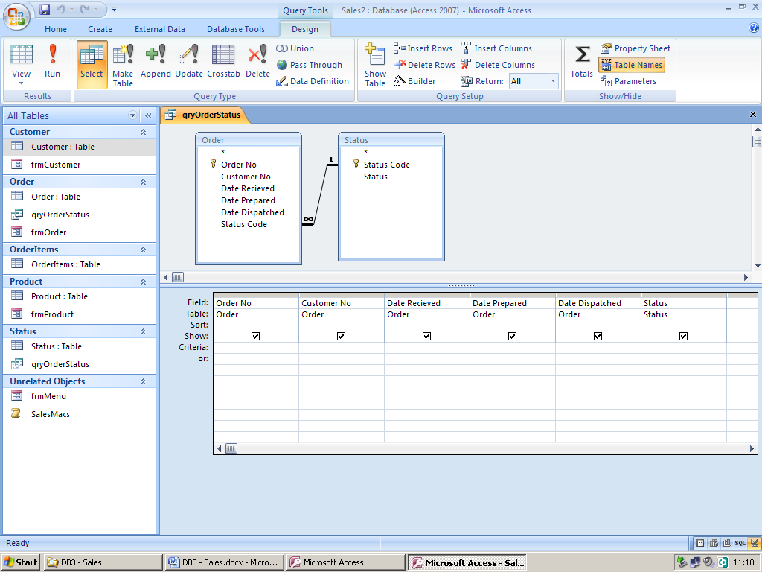

1. Load the form frmCustomer and use the subform wizard to insert a subform. The subform should be saved with the name subformqryCustomerOrder.

The completed form should appear similar to that shown below.

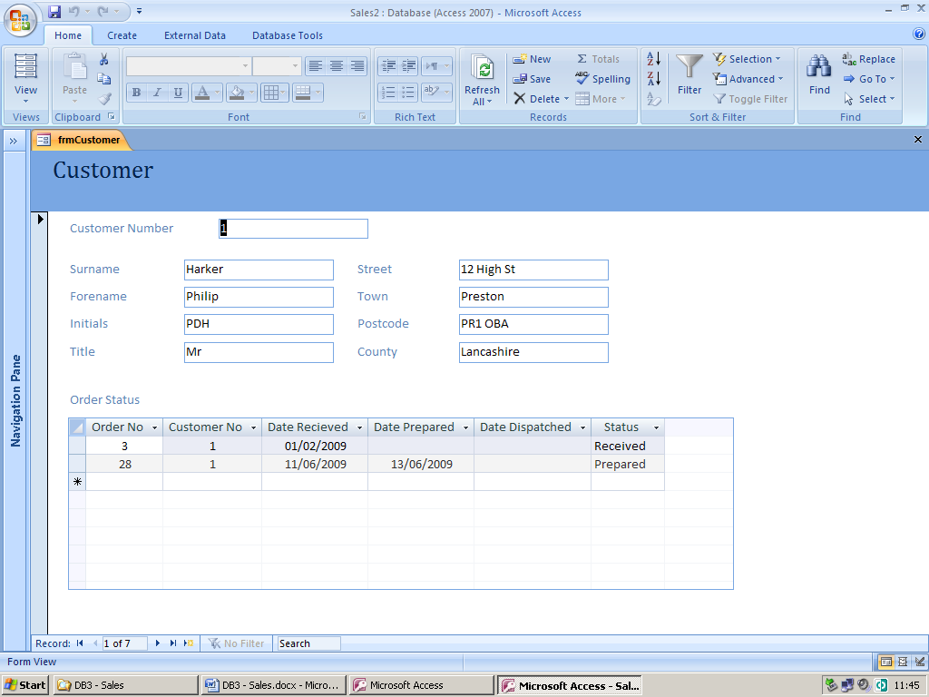

### Task 3

You are now going to improve the Order Form frmOrder.

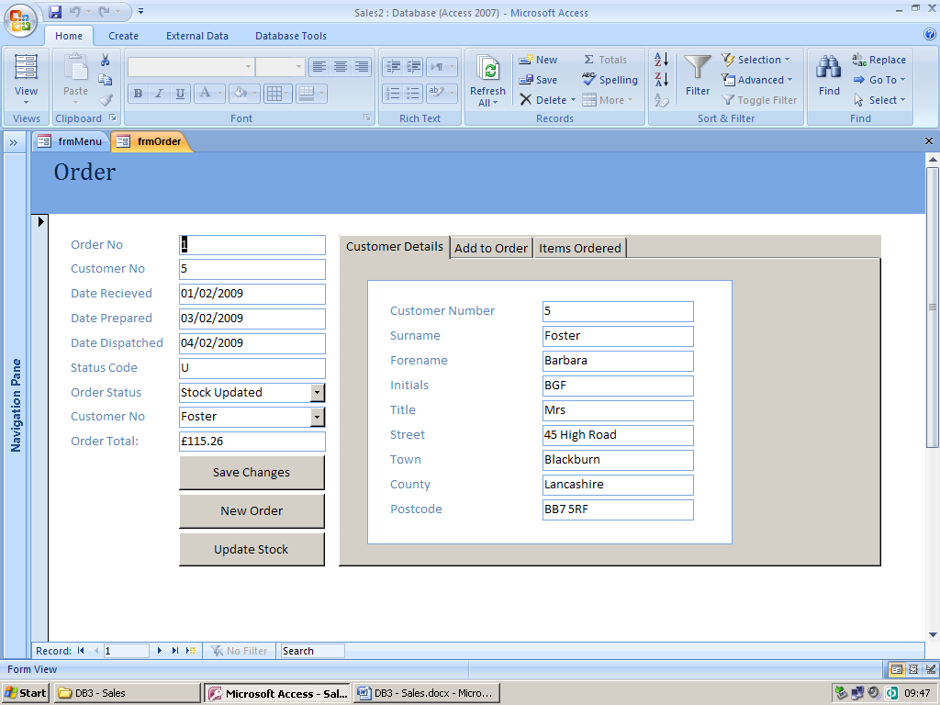

1. The form needs to have a Control Tab added to it. This is a device which can be used to prevent a form becoming too cluttered.
2. The Customer Details is to be added to the Control Tab. This is to subform subformCustomer which is to be based on the Customer table.
3. The Items Ordered tab is a subform named subformqryOrderItems which is based on a query called qryOrderItems. The query qryOrderItems is shown below and needs to be setup.  
     
   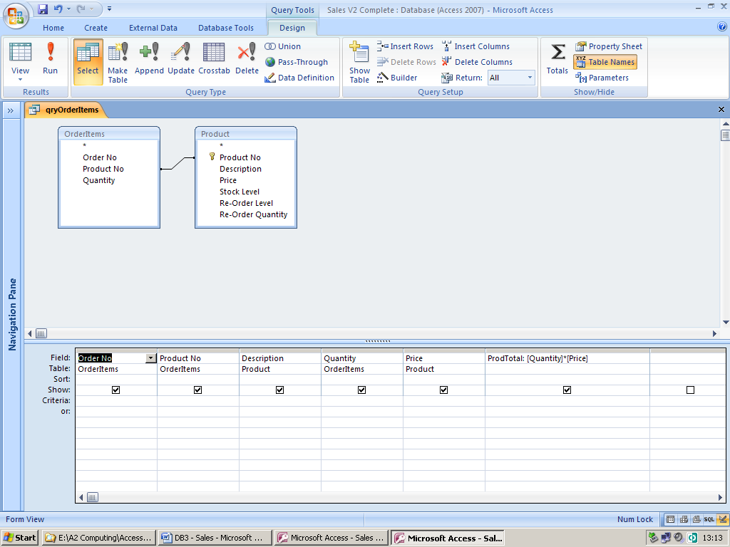
4. The “Add Item to Order” subform is to be called frmOrderItems and should be based on the table OrderItems table. The form should be made to appear similar to that shown below.  
     
   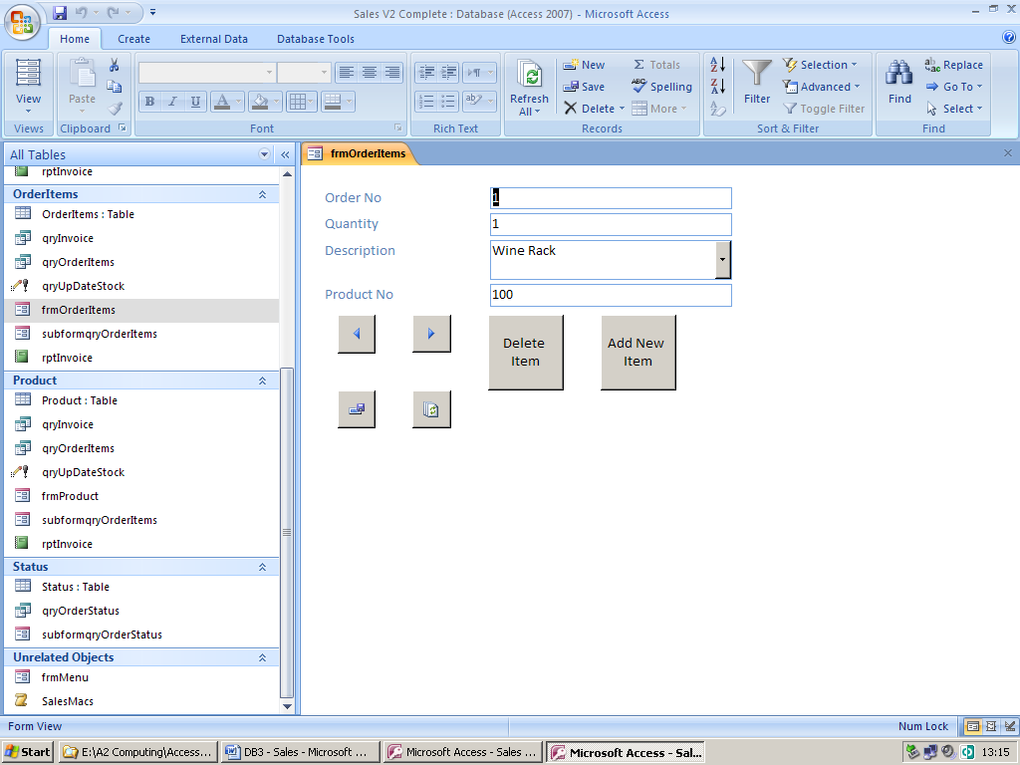
5. The “Update Stock” command button runs a series of queries which updates the stock levels and change the status of the order from “R” (Received) to “U” (Stock Updaed). An update query called qryUpDateStock is shown below. Also the update query that changes the status of the order which is called qryChangeOrderStatus is shown below that.

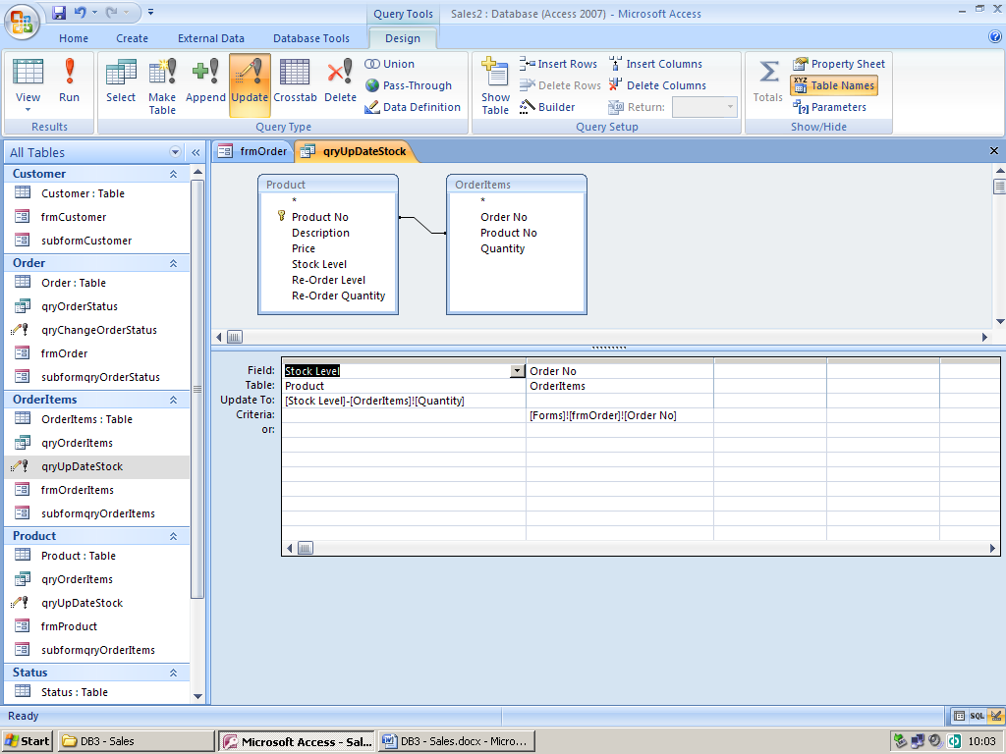  
  
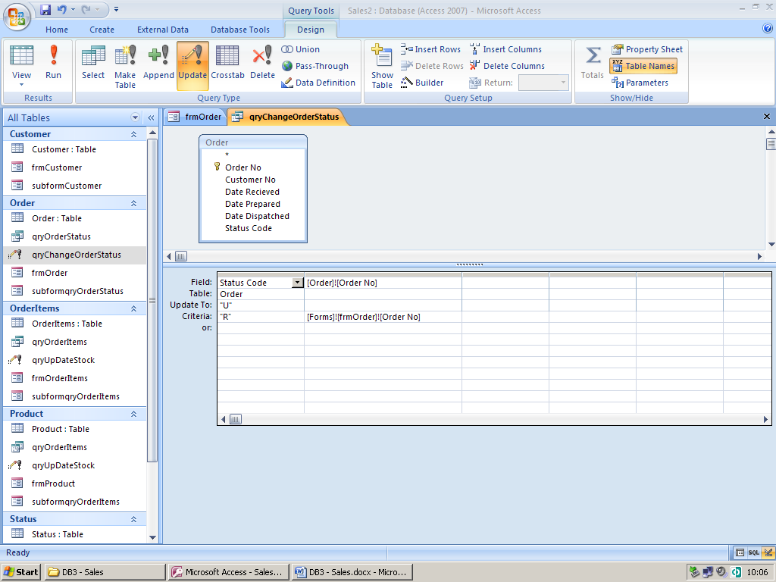

1. You are now going to add a text box which will display the value of the order. The figure displayed in the text box is calculated using a DSUM function.

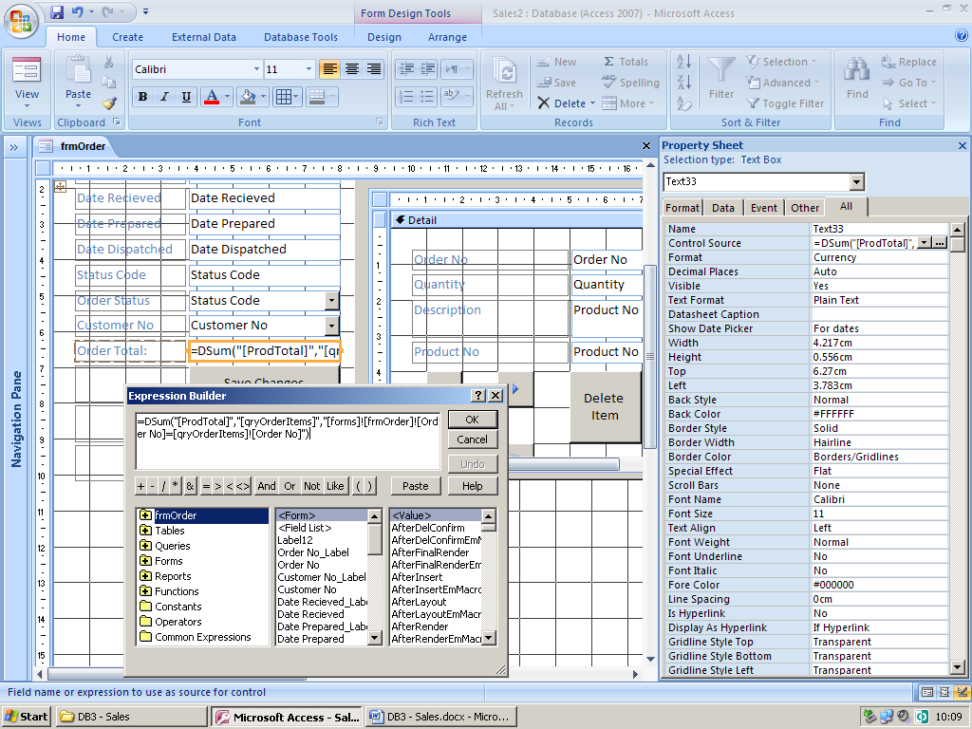

1. The “Save Changes” command button is to be added using the command button wizard.
2. The invoice is based on the query qryInvoice which is shown below. The invoice is to be created by using the report wizard although it will need to be edited in design view to obtain the format required.

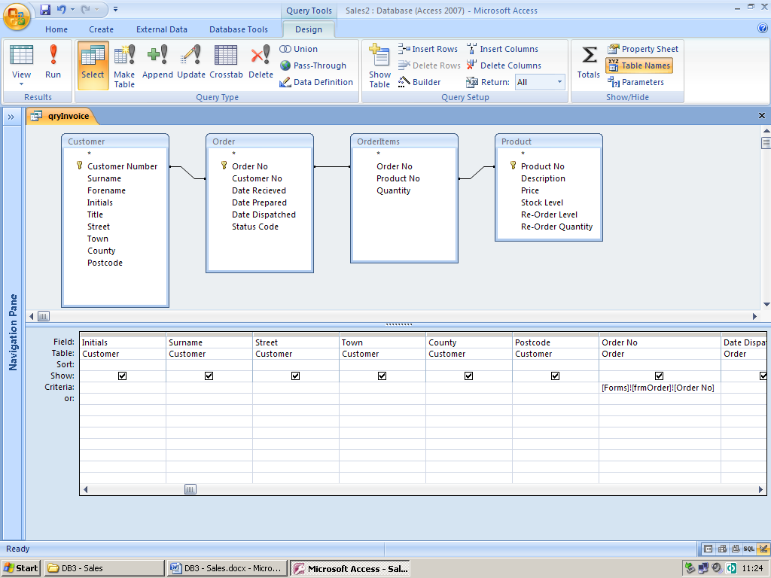

1. Further macros and features will need to be added to make a fully functioning system.